Advanced Image Processing

Final Exam.

Student No.: 　 　　　　 Name: 　　 　　　 109/12

1. 是非題(T/F test) (30%)

( ) 1. If degradation is systematic (有條理的), it can be suppressed (抑制) by brightness correction. The brightness correction method can be used only if the image degradation process is stable.

( ) 2. The aim of histogram equalization is to create an image with equally distributed brightness levels over the whole brightness scale.

( ) 3. If the area of the image is invariant under a geometric transformation, then its Jacobia determinant J = 1.

( ) 4. Gray-scale transformations depend on the position of the pixel in the image.

( ) 5. The bilinear transformation includes typical geometric transformations such as rotation and translation, but not scaling.

( ) 6. The position error of nearest-neighborhood brightness interpolation is at least half a pixel.

( ) 7. Image smoothing uses redundancy in image data to suppress noise, usually by some form of averaging of brightness values in some neighborhood.

( ) 8. “Averaging according to inverse gradient” is a linear method that avoids edge blurring.

( ) 9. Median filter is a nonlinear smoothing method.

( ) 10. The edge direction is rotated with respect to the gradient direction by .

( ) 11. The Prewitt operator approximates the first derivative. The gradient is estimated in eight (for a  convolution mask) possible directions, and the convolution result of largest magnitude indicates the gradient direction.

( ) 12. Zero-crossings is an edge detection technique using the first derivative.

( ) 13. The definition of Laplacian of Gaussian ($∇^{2}G$ LoG) operator is the difference of two Gaussian averaging masks with substantially different variance.

( ) 14. The one response criterion of edge detector indicates that the important edges should not be missed.

( ) 15. The Laplacian operator for edge detection has the same properties in all directions and is therefore invariant to rotation.

( ) 16. Non-maximal suppression is an edge thinning technique.

( ) 17. Edge detectors based on parametric models describe edges more precisely than convolution-based edge detectors. However, their computational requirements are much higher.

( ) 18. Edge can be enhanced by high-pass frequency-domain filtering and noise can be suppressed by low-pass frequency-domain filtering.

( ) 19. Otsu’s algorithm is one kind of optimal thresholding.

( ) 20. Let  be the cut-off frequency coincides with the dispersion , $D\left(u,v\right)=D\left(r\right)=\sqrt{u^{2}+v^{2}}$ be an isotropic (等向的) filter (for example, ), then the Fourier spectrum of the filter  is a high-pass Gaussian filter.

( ) 21. The high-pass filter is created easily from the low-pass filter. If the Fourier frequency spectrum of a low-pass filter is $H_{low}$, the high-pass filter can be created by just flipping it vertically $H_{high}=1/H_{low}$.

( ) 22. A corner in an image can be defined as a pixel in whose immediate neighborhood there are two dominant, different edge directions.

( ) 23. Homomorphic filtering is used to remove multiplicative noise.

( ) 24. In Harris corner detector, let  and  be the eigenvalues of the Harris matrix A, a corner has been found if both eigenvalues are small.

( ) 25. Invariance to monotonic transformations is one property of maximally stable extremal Regions (MSERs).

( ) 26. A complete segmentation of an image $R$ is a finite set of regions $R_{1},…,R_{S},$, where , and $R_{i}∩R_{j}=∅, i≠j.$

( ) 27. $p$-tile thresholding method uses a prior information to choose a threshold $T$ such that $1/p$ of the image area has gray values less than $T$.

( ) 28. The Hough transform was designed to detect straight lines and curves. However, this approach is very sensitive to imperfect data or noise.

( ) 29. Homogeneity (同質性) is an important property of regions. Let $S$ be the total number of regions in an image, and $H\left(R_{i}\right)$ be a binary homogeneity evaluation of the region $R_{i}$, the criteria for homogeneity can be defined as $H\left(R_{i}\right)=TRUE, i=1,2,…,S$, and $H\left(R_{i}∪R_{j}\right)=FALSE,i≠j.$

( ) 30. Region splitting is the opposite of region merging. Region splitting begins with each pixel represented as a single region.

1. 簡答證明題(assay question)
2. (2%) Here shows an edge detection mask, what is the value of *a*?

$$h= \frac{1}{16}\left[\begin{matrix}1 & 2 & 1 \\ 2 & a & 2 \\ 1 & 2 & 1\end{matrix}\right]$$

ANS:

1. (2%) Here shows a smoothing mask, what is the value of *b*?

$$h= \frac{1}{16}\left[\begin{matrix}1 & 2 & 1 \\ 2 & b & 2 \\ 1 & 2 & 1\end{matrix}\right]$$

ANS:

1. (2%) What kind of objects can be detected by the following masks?



ANS:

1. (6%) (a) How to remove the salt-and-pepper noises?

(b) How to remove the periodic (周期性的) noises?

(c) How to remove Gaussian noises?

ANS:

1. (3%) Compare with region merging, region splitting does not result in the same segmentation even if the same homogeneity criteria are used. Why?

ANS:

1. (2%) Hough transform is a very powerful technique for detection. What is the main problem of Hough transform?

ANS:

1. (4%) Corners is one kind of interest points for the correspondence problem.   
   (a) (2%) What is a corner? (please give the definition of a corner)  
   (b) (2%) Corners serves better than edges (lines) when the correspondence problem is to be solved because of the aperture problem (孔徑問題). What is the aperture problem?

ANS:

1. 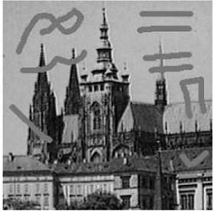(2%) The following image is one example of corrupted (篡改;塗改) image. How to remove this kind of noise?

1. (4%) What is the meanings of the difference of Gaussian? Can you give an application which can use the convolution masks of the difference of Gaussian?

ANS:

1. (4%) Zero-crossings is an edge detection technique. What is zero-crossings? What is the main advantages of zero-crossings?

ANS:

1. (2%) Three most common brightness interpolation methods are nearest neighbor, linear and bi-cubic. Please explain the nearest neighbor interpolation method.

ANS:

1. (3%) Please explain what the hysteresis (滯後作用) approach used by Canny edge detection is.

ANS:

1. (2%) A straight line can be represented by the equation $x_{2}=kx_{1}+q$ with two the parameters $k$ and $q$. Why this equation is not suitable to represent a straight line in Hough transforms?

ANS:

1. (4%) (a) (2%) Please draw the corresponding quadtree of the following image.

(b) (2%) What is the **drawback** of segmentation quadtree?

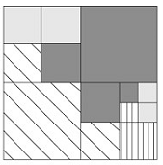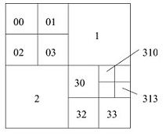

1. (2%) A transformation $T$ of original brightness $p$ from scale $[p_{0},p_{k}]$ into brightness $q$ from a new scale  is given by . Given an original image as Figure (a), can you draw the transformation  if the output image is (b)?

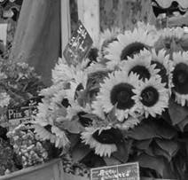 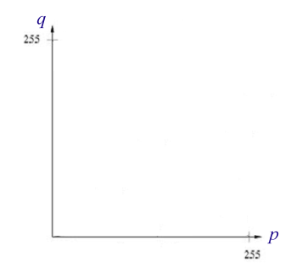 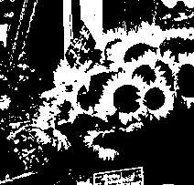

1. original image Function *T* (b) output image
2. (4%) (1) (2%) Figure (a) shows the original image, and Figure (b) shows the filtered image. What kind of filters is used in the frequency domain? Low-pass filters? High-pass filters? Band-pass filters? Or homomorphic filtering? ANS:

(2) (2%) If the filtered image is shown in Figure (c), then what kind of the filters is used in the frequency domain? ANS:

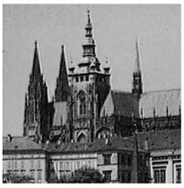 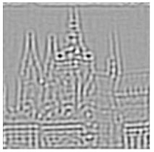 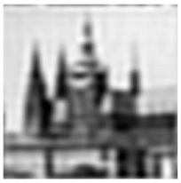

(a) (b) (c)

1. (4%) Here shows Otsu’s threshold detection algorithm, please fill in the blanks.

**Algorithm 6.2 Otsu’s threshold detection**

1. For an image $I$ on  gray levels, compute the gray-level histogram $H\left(0\right),H\left(1\right),…,H\left(G-1\right)$. Normalize the histogram by dividing through by the number of pixels in –the histogram now represents the probability of each gray level.

2. For each possible threshold $t=0,1,…,G-2$ partition the histogram into background  (gray-levels less than or equal to ), and foreground  (gray-levels more than ).

3. Compute , $σ_{B}\left(t\right),σ_{F}(t)$, the variance of the background and foreground gray-levels. Compute the probability of a pixel being background

 and  similarly. Set



and select as threshold $\hat{t}={arg min}_{t}\left(σ\left(t\right)\right)$ .

1. (3%) Here shows a histogram equalization algorithm, please fill in the blanks.

**Algorithm 5.1 Histogram equalization**

1. For an  image of $G$ gray-levels, initialize an array $H$ of length  to 0.

2. From the image histogram: Scan every pixel $p$ – if it has intensity $g_{p}$, perform



Then let $g_{min}$ be the minimum  for which .

3. Form the cumulative image histogram :



 ,

Let .

4. Set



5. Rescan the image and write an output image with gray-levels $g_{q}$, setting



1. (4%) Given a 2D Gaussian filter



where  is the standard deviation. Please derive , and $\frac{∂G}{∂x}$ the Laplacian of Gaussian . ( PS. )

1. (2%) A geometric transform is a vector function $T$ that maps the pixel $(x,y)$ to a new position $(x^{'},y^{'})$. , where ,. The geometric transform can be approximated by an affine transform.

$$x^{'}=a_{0}+a_{1}x+a_{2}y; y'=b_{0}+b_{1}x+b_{2}y$$

A Jacobia determinant  can provides information about how the co-ordinate system changes. $J=\left|\frac{∂(x^{'},y^{'})}{∂(x,y)}\right|$

Please show the Jacobia determinant for the transform.

1. (6%) Given an inner boundary tracing algorithm as follows.

**Algorithm: Inner boundary tracing in 8-connectivity**

1. Search the image from top left until a pixel  of a new region is found; this has the minimum column value of all pixels of that region having the minimum row value.  is a starting pixel of the region border.

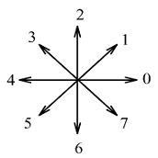Define a variable $dir$ which stores the direction of the previous move along the border from the previous border element to the current border elements. Assign $dir=7$  
 if the border is detected in 8-connectivity.

2. Search the $3×3$ neighborhood of the current pixel in   
an anti-clockwise direction, beginning the neighborhood   
search in the pixel positioned in the direction

 $\left(dir+3\right) mod 4$ $\left(dir+7\right) mod 8$ if  is even. (8-connectivity)

 $\left(dir+6\right) mod 8$ if  is odd. (8-connectivity)

The first pixel found with the same value as the current  
pixel is a new boundary element . Update the  value.

3. If the current boundary element  is equal to the second border element , and if the previous border element $P_{n-1}$ is equal to , stop. Otherwise repeat step 2.

4. Pixels $P_{0},…,P_{n-2}$ are now the detected inner border.

**Questions:**

1. (2%) What are the values at *P*1and *P*2?

ANS:

1. (4%) What is the starting search pixel after *P*1and *P*2? Please mark them in the image.

|  |  |  |  |  |  |  |  |  |  |  |
| --- | --- | --- | --- | --- | --- | --- | --- | --- | --- | --- |
|  |  |  |  |  |  |  |  |  |  |  |
|  |  |  |  |  |  |  |  |  |  |  |
|  |  |  |  |  |  |  |  | *P*2 |  |  |
|  |  |  |  |  |  |  |  |  |  |  |
|  |  |  |  |  |  |  |  |  |  |  |
|  |  |  |  |  | *P*1 |  |  |  |  |  |
|  |  |  |  |  |  |  |  |  |  |  |
|  |  |  |  |  |  |  |  |  |  |  |

1. (3%) Here define four kind of inner boundary pixels of a region $R$:

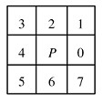If $Q$ denote outside the region $R$, then pixel $P∈R$ is

a LEFT pixel of $R$ if $P_{4}(P)∈Q$

a RIGHT pixel of $R$ if $P_{0}(P)∈Q$

an UPPER pixel of $R$ if $P_{2}(P)∈Q$

a LOWER pixel of $R$ if $P_{6}(P)∈Q$

For example, $P_{4}\left(P\right)$ denotes the pixel immediately to the left of pixel $P$.

Let $LEFT\left(R\right), RIGHT\left(R\right),UPPER\left(R\right),LOWER(R)$ represent the corresponding subsets of $R$. How to define the extended boundary $EB$?

$EB=\{P:P∈LEFT\left(R\right)$} $∪$ {$P:P∈UPPER\left(R\right)$}

$∪$ { $:P∈RIGHT\left(R\right)$} $∪$ { $:P∈RIGHT\left(R\right)$}

$∪$ { $:P∈LOWER\left(R\right)$}